[](https://ok.ru/dk?cmd=PopLayerPhoto&st.layer.cmd=PopLayerPhotoOuter&st.layer.type=GROUP&st.layer.revNav=off&st.layer.limitedUi=false&st.layer.closeLayers=off&st.layer.sphotoIds=890101891252;890101889972;890101890228;890101890484;890101890740;890101890996&st.layer.showNav=on&st.layer.photoAlbumId=53539413622964&st.layer.epm=off&st.layer.photoId=890101891252&st.layer.wasRedirect,=off&st.layer.opl=off&st.layer.navStartPhotoId=890101891252&st.layer.navStartAlbumId,=53539413622964&st.layer.sbd=off&st.cmd=userMain&st._aid=GroupTopicLayer_openPhotoLayer)

[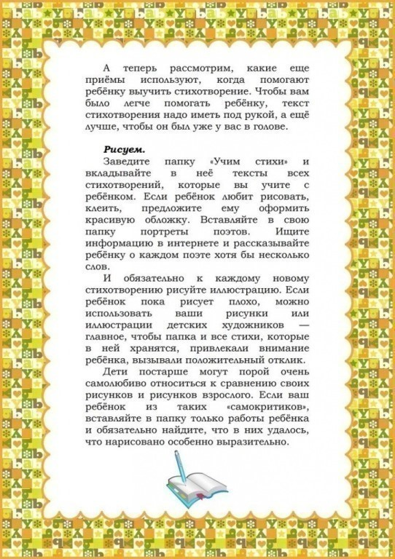](https://ok.ru/dk?cmd=PopLayerPhoto&st.layer.cmd=PopLayerPhotoOuter&st.layer.type=GROUP&st.layer.revNav=off&st.layer.limitedUi=false&st.layer.closeLayers=off&st.layer.sphotoIds=890101891252;890101889972;890101890228;890101890484;890101890740;890101890996&st.layer.showNav=on&st.layer.photoAlbumId=53539413622964&st.layer.epm=off&st.layer.photoId=890101889972&st.layer.wasRedirect,=off&st.layer.opl=off&st.layer.navStartPhotoId=890101889972&st.layer.navStartAlbumId,=53539413622964&st.layer.sbd=off&st.cmd=userMain&st._aid=GroupTopicLayer_openPhotoLayer)

[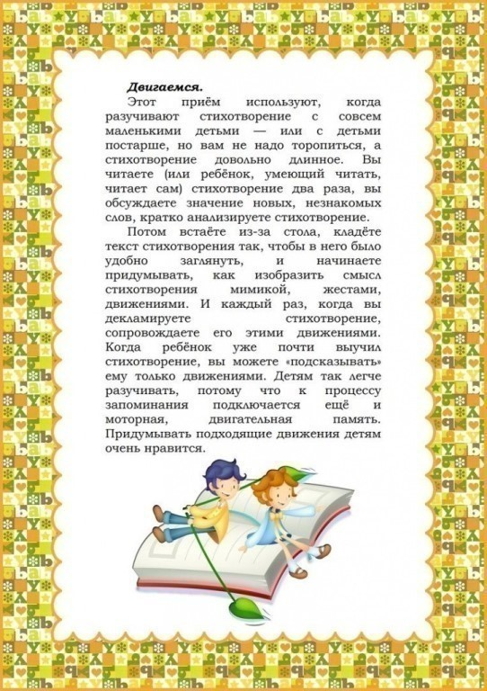](https://ok.ru/dk?cmd=PopLayerPhoto&st.layer.cmd=PopLayerPhotoOuter&st.layer.type=GROUP&st.layer.revNav=off&st.layer.limitedUi=false&st.layer.closeLayers=off&st.layer.sphotoIds=890101891252;890101889972;890101890228;890101890484;890101890740;890101890996&st.layer.showNav=on&st.layer.photoAlbumId=53539413622964&st.layer.epm=off&st.layer.photoId=890101890228&st.layer.wasRedirect,=off&st.layer.opl=off&st.layer.navStartPhotoId=890101890228&st.layer.navStartAlbumId,=53539413622964&st.layer.sbd=off&st.cmd=userMain&st._aid=GroupTopicLayer_openPhotoLayer)

[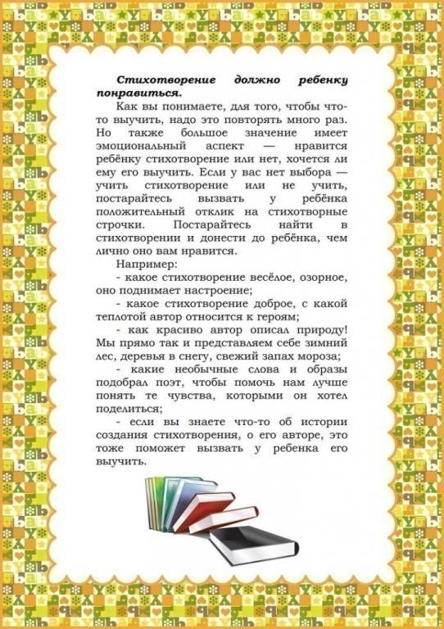](https://ok.ru/dk?cmd=PopLayerPhoto&st.layer.cmd=PopLayerPhotoOuter&st.layer.type=GROUP&st.layer.revNav=off&st.layer.limitedUi=false&st.layer.closeLayers=off&st.layer.sphotoIds=890101891252;890101889972;890101890228;890101890484;890101890740;890101890996&st.layer.showNav=on&st.layer.photoAlbumId=53539413622964&st.layer.epm=off&st.layer.photoId=890101890484&st.layer.wasRedirect,=off&st.layer.opl=off&st.layer.navStartPhotoId=890101890484&st.layer.navStartAlbumId,=53539413622964&st.layer.sbd=off&st.cmd=userMain&st._aid=GroupTopicLayer_openPhotoLayer)

[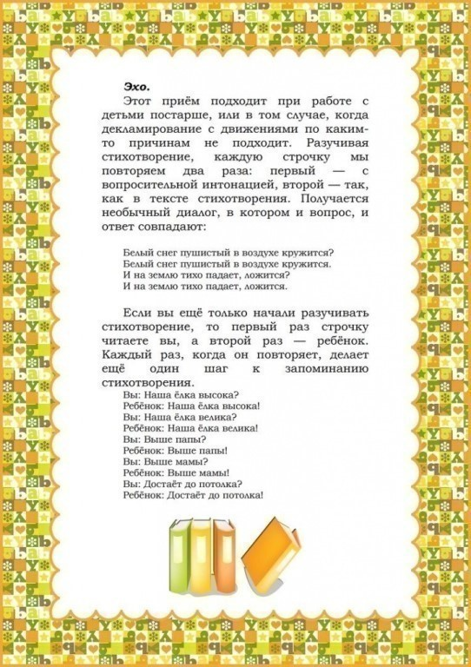](https://ok.ru/dk?cmd=PopLayerPhoto&st.layer.cmd=PopLayerPhotoOuter&st.layer.type=GROUP&st.layer.revNav=off&st.layer.limitedUi=false&st.layer.closeLayers=off&st.layer.sphotoIds=890101891252;890101889972;890101890228;890101890484;890101890740;890101890996&st.layer.showNav=on&st.layer.photoAlbumId=53539413622964&st.layer.epm=off&st.layer.photoId=890101890740&st.layer.wasRedirect,=off&st.layer.opl=off&st.layer.navStartPhotoId=890101890740&st.layer.navStartAlbumId,=53539413622964&st.layer.sbd=off&st.cmd=userMain&st._aid=GroupTopicLayer_openPhotoLayer)

[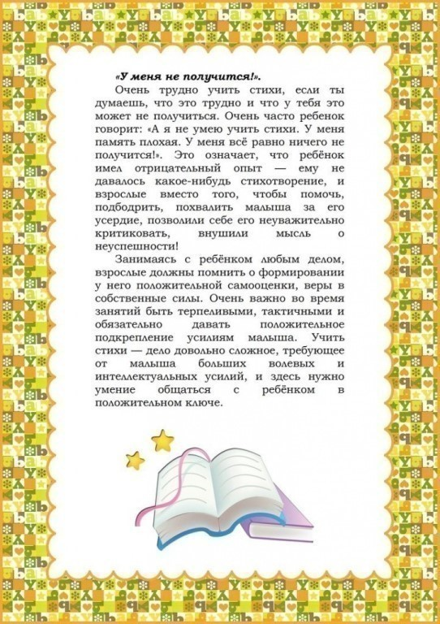](https://ok.ru/dk?cmd=PopLayerPhoto&st.layer.cmd=PopLayerPhotoOuter&st.layer.type=GROUP&st.layer.revNav=off&st.layer.limitedUi=false&st.layer.closeLayers=off&st.layer.sphotoIds=890101891252;890101889972;890101890228;890101890484;890101890740;890101890996&st.layer.showNav=on&st.layer.photoAlbumId=53539413622964&st.layer.epm=off&st.layer.photoId=890101890996&st.layer.wasRedirect,=off&st.layer.opl=off&st.layer.navStartPhotoId=890101890996&st.layer.navStartAlbumId,=53539413622964&st.layer.sbd=off&st.cmd=userMain&st._aid=GroupTopicLayer_openPhotoLayer)