[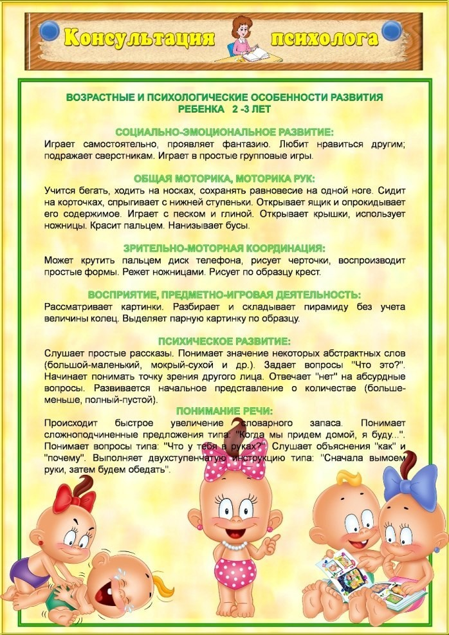](https://ok.ru/dk?cmd=PopLayerPhoto&st.layer.cmd=PopLayerPhotoOuter&st.layer.type=GROUP&st.layer.revNav=off&st.layer.limitedUi=false&st.layer.sphotoIds=866255408436;866255408692;866255408948;866255409204;866255409460;866255409716;866255409972&st.layer.showNav=on&st.layer.photoAlbumId=57249062780980&st.layer.epm=off&st.layer.photoId=866255408436&st.layer.opl=off&st.layer.navStartPhotoId=866255408436&st.layer.sbd=off&st.cmd=userMain&st._aid=GroupTopicLayer_openPhotoLayer)

[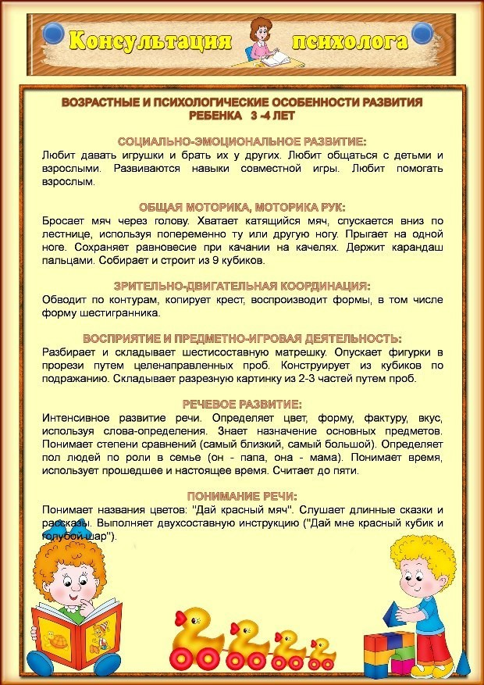](https://ok.ru/dk?cmd=PopLayerPhoto&st.layer.cmd=PopLayerPhotoOuter&st.layer.type=GROUP&st.layer.revNav=off&st.layer.limitedUi=false&st.layer.sphotoIds=866255408436;866255408692;866255408948;866255409204;866255409460;866255409716;866255409972&st.layer.showNav=on&st.layer.photoAlbumId=57249062780980&st.layer.epm=off&st.layer.photoId=866255408692&st.layer.opl=off&st.layer.navStartPhotoId=866255408692&st.layer.sbd=off&st.cmd=userMain&st._aid=GroupTopicLayer_openPhotoLayer)

[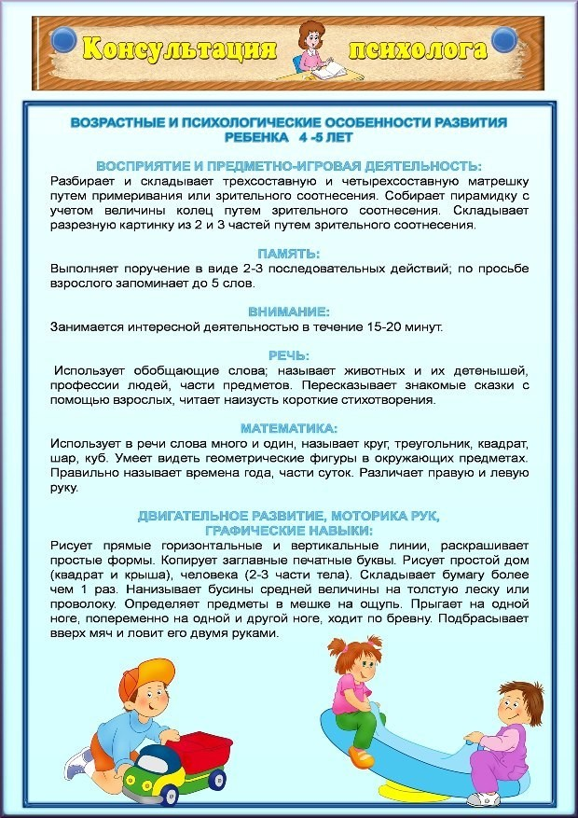](https://ok.ru/dk?cmd=PopLayerPhoto&st.layer.cmd=PopLayerPhotoOuter&st.layer.type=GROUP&st.layer.revNav=off&st.layer.limitedUi=false&st.layer.sphotoIds=866255408436;866255408692;866255408948;866255409204;866255409460;866255409716;866255409972&st.layer.showNav=on&st.layer.photoAlbumId=57249062780980&st.layer.epm=off&st.layer.photoId=866255408948&st.layer.opl=off&st.layer.navStartPhotoId=866255408948&st.layer.sbd=off&st.cmd=userMain&st._aid=GroupTopicLayer_openPhotoLayer)

[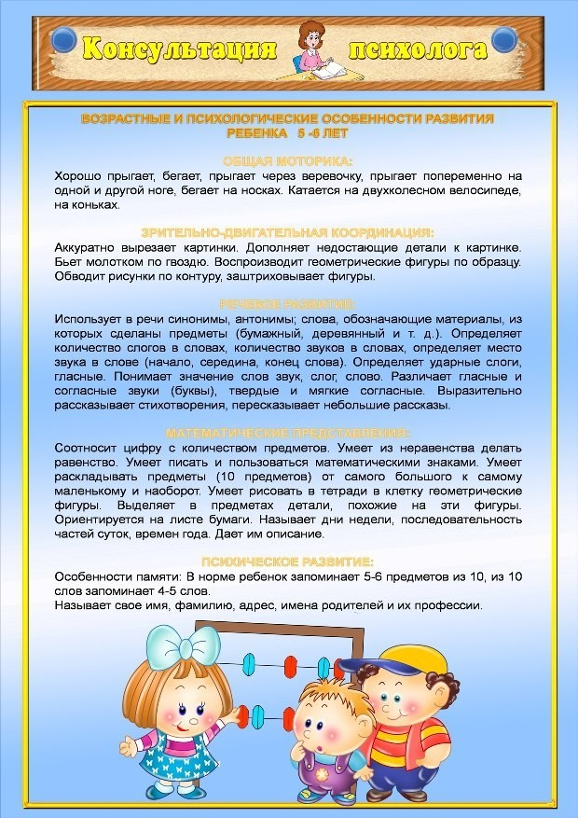](https://ok.ru/dk?cmd=PopLayerPhoto&st.layer.cmd=PopLayerPhotoOuter&st.layer.type=GROUP&st.layer.revNav=off&st.layer.limitedUi=false&st.layer.sphotoIds=866255408436;866255408692;866255408948;866255409204;866255409460;866255409716;866255409972&st.layer.showNav=on&st.layer.photoAlbumId=57249062780980&st.layer.epm=off&st.layer.photoId=866255409204&st.layer.opl=off&st.layer.navStartPhotoId=866255409204&st.layer.sbd=off&st.cmd=userMain&st._aid=GroupTopicLayer_openPhotoLayer)

[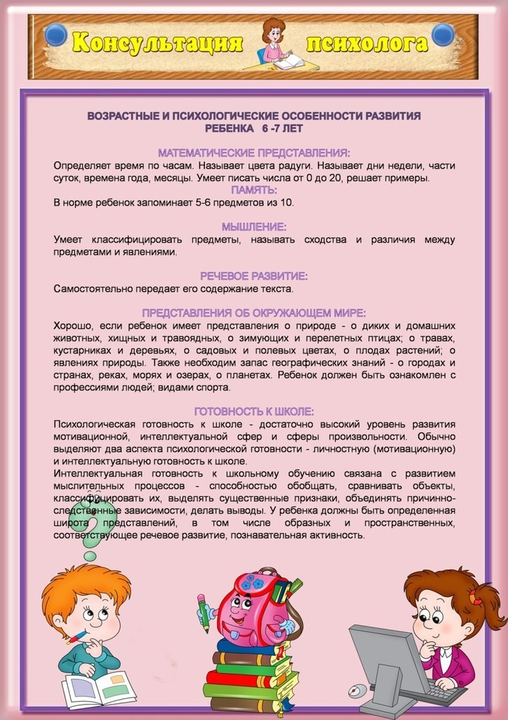](https://ok.ru/dk?cmd=PopLayerPhoto&st.layer.cmd=PopLayerPhotoOuter&st.layer.type=GROUP&st.layer.revNav=off&st.layer.limitedUi=false&st.layer.sphotoIds=866255408436;866255408692;866255408948;866255409204;866255409460;866255409716;866255409972&st.layer.showNav=on&st.layer.photoAlbumId=57249062780980&st.layer.epm=off&st.layer.photoId=866255409460&st.layer.opl=off&st.layer.navStartPhotoId=866255409460&st.layer.sbd=off&st.cmd=userMain&st._aid=GroupTopicLayer_openPhotoLayer)