[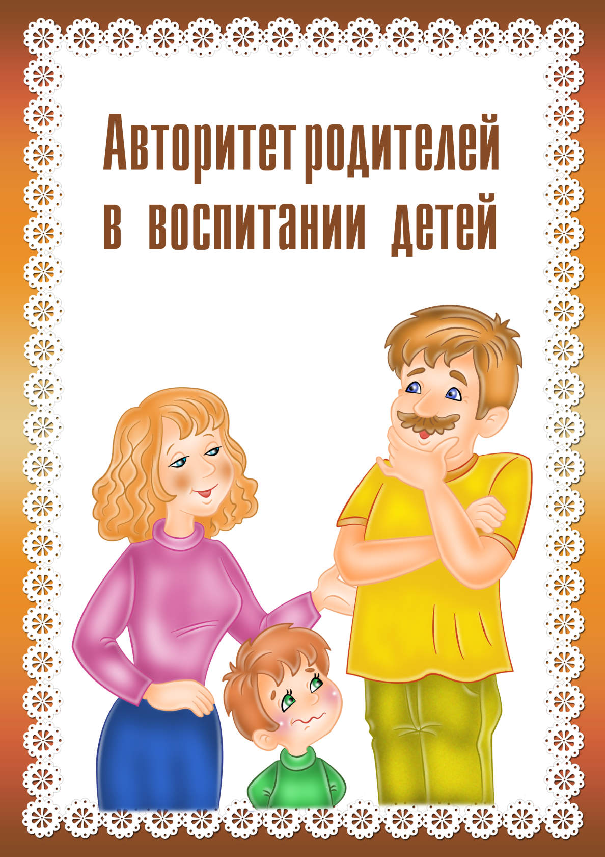](https://ok.ru/dk?cmd=PopLayerPhoto&st.layer.cmd=PopLayerPhotoOuter&st.layer.type=GROUP&st.layer.revNav=off&st.layer.limitedUi=false&st.layer.closeLayers=off&st.layer.sphotoIds=865748688451;865748688195;865748687939;865748687683;865748687427&st.layer.showNav=on&st.layer.photoAlbumId=53073113251907&st.layer.epm=off&st.layer.photoId=865748688451&st.layer.opl=off&st.layer.navStartPhotoId=865748688451&st.layer.sbd=off&st.cmd=userMain&st._aid=GroupTopicLayer_openPhotoLayer)

[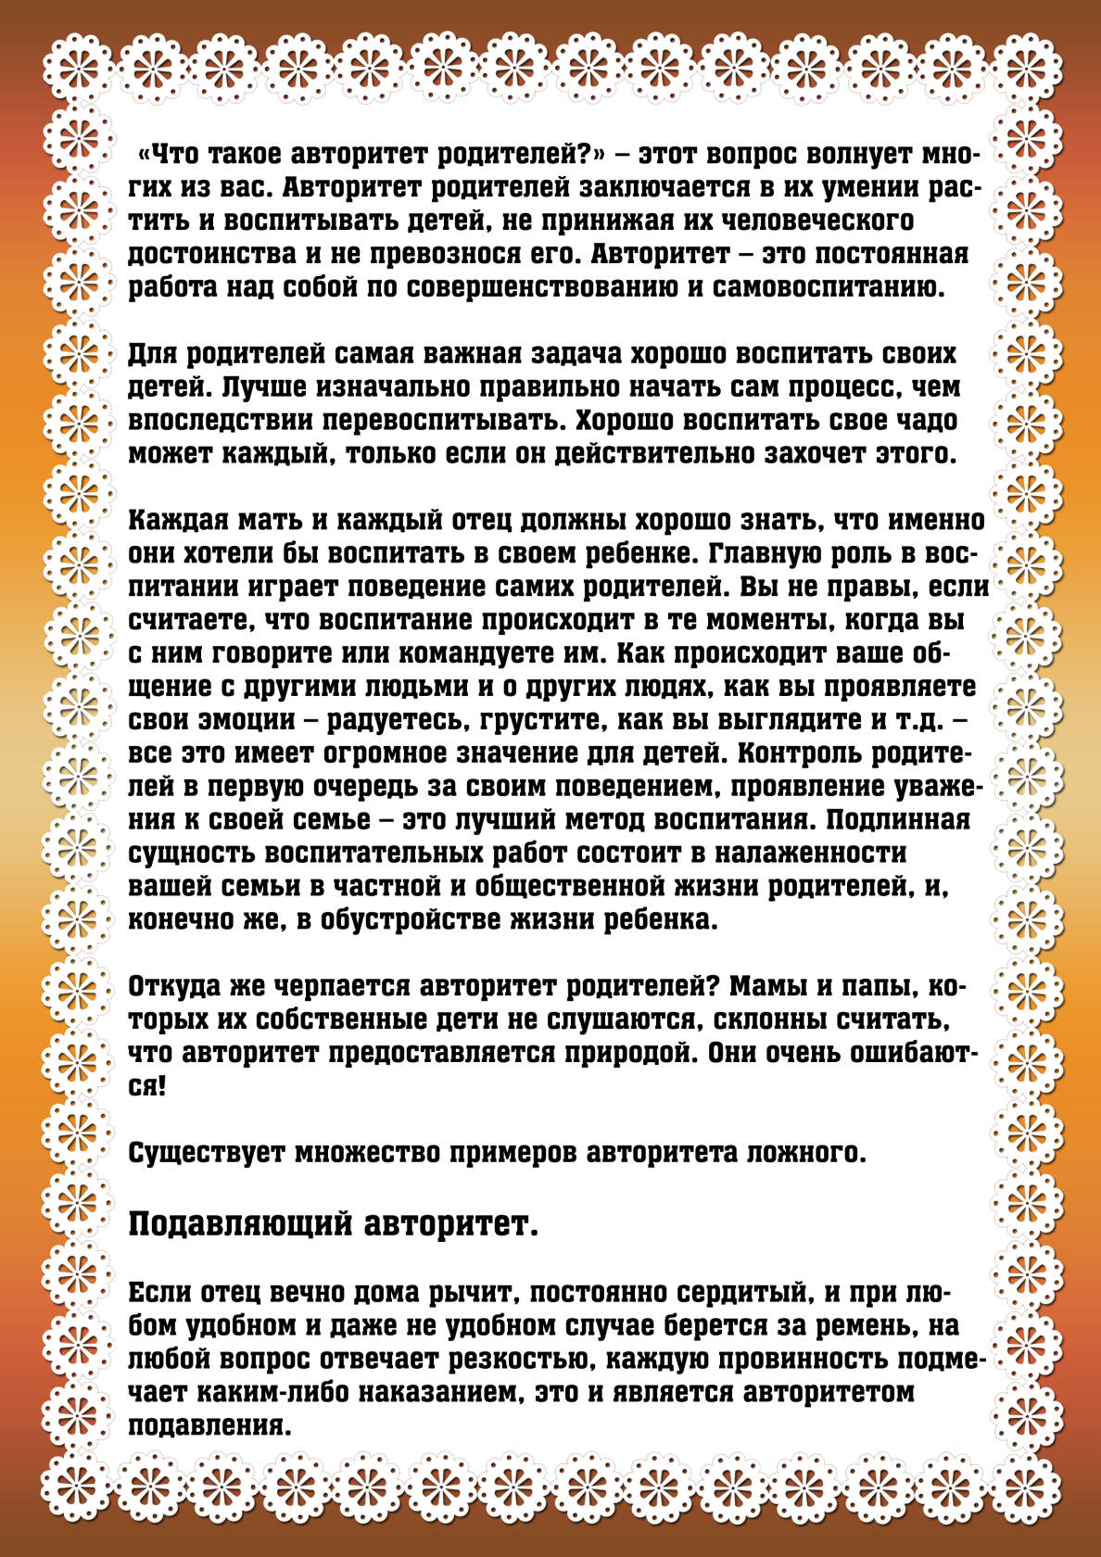](https://ok.ru/dk?cmd=PopLayerPhoto&st.layer.cmd=PopLayerPhotoOuter&st.layer.type=GROUP&st.layer.revNav=off&st.layer.limitedUi=false&st.layer.closeLayers=off&st.layer.sphotoIds=865748688451;865748688195;865748687939;865748687683;865748687427&st.layer.showNav=on&st.layer.photoAlbumId=53073113251907&st.layer.epm=off&st.layer.photoId=865748688195&st.layer.opl=off&st.layer.navStartPhotoId=865748688195&st.layer.sbd=off&st.cmd=userMain&st._aid=GroupTopicLayer_openPhotoLayer)

[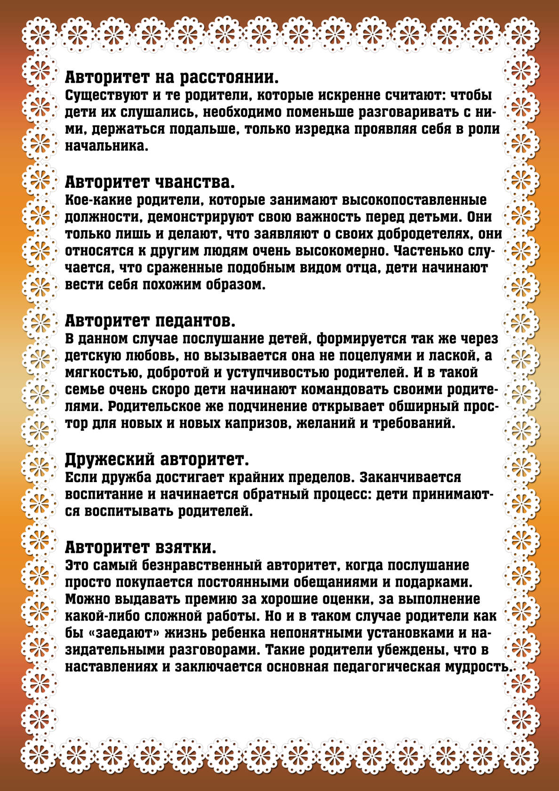](https://ok.ru/dk?cmd=PopLayerPhoto&st.layer.cmd=PopLayerPhotoOuter&st.layer.type=GROUP&st.layer.revNav=off&st.layer.limitedUi=false&st.layer.closeLayers=off&st.layer.sphotoIds=865748688451;865748688195;865748687939;865748687683;865748687427&st.layer.showNav=on&st.layer.photoAlbumId=53073113251907&st.layer.epm=off&st.layer.photoId=865748687939&st.layer.opl=off&st.layer.navStartPhotoId=865748687939&st.layer.sbd=off&st.cmd=userMain&st._aid=GroupTopicLayer_openPhotoLayer)

[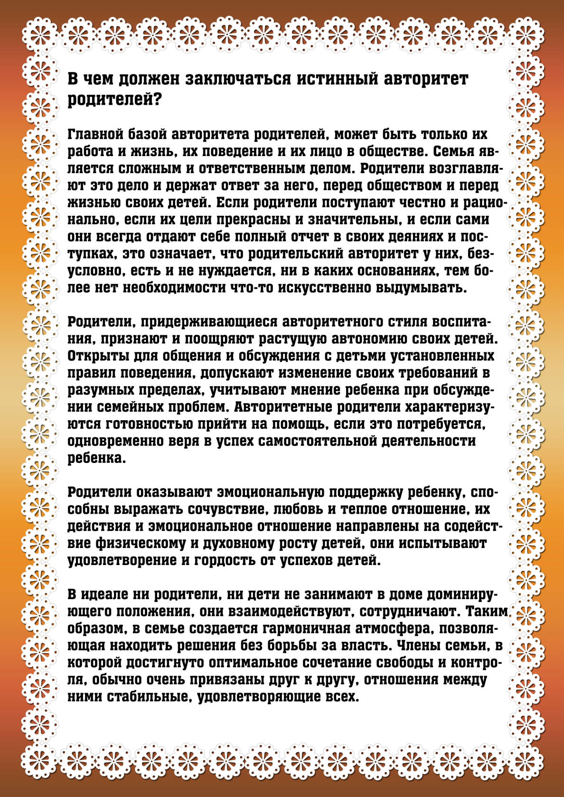](https://ok.ru/dk?cmd=PopLayerPhoto&st.layer.cmd=PopLayerPhotoOuter&st.layer.type=GROUP&st.layer.revNav=off&st.layer.limitedUi=false&st.layer.closeLayers=off&st.layer.sphotoIds=865748688451;865748688195;865748687939;865748687683;865748687427&st.layer.showNav=on&st.layer.photoAlbumId=53073113251907&st.layer.epm=off&st.layer.photoId=865748687683&st.layer.opl=off&st.layer.navStartPhotoId=865748687683&st.layer.sbd=off&st.cmd=userMain&st._aid=GroupTopicLayer_openPhotoLayer)

[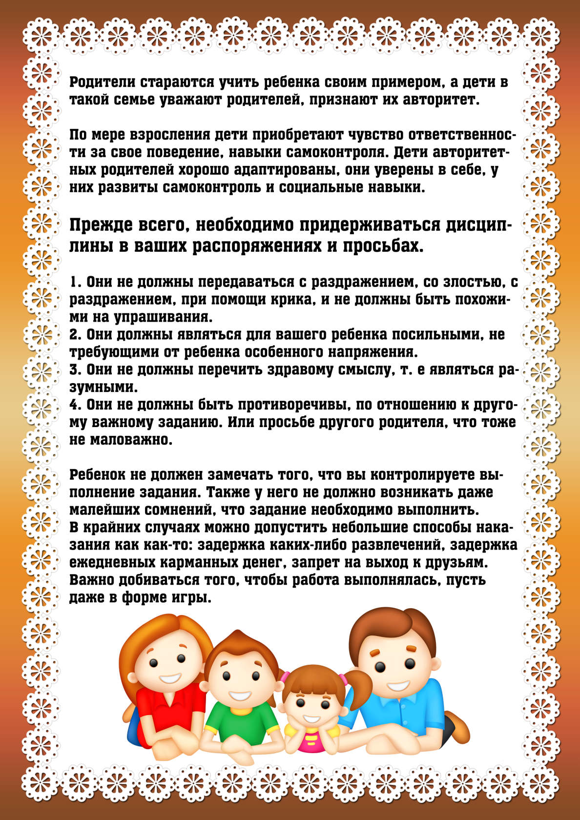](https://ok.ru/dk?cmd=PopLayerPhoto&st.layer.cmd=PopLayerPhotoOuter&st.layer.type=GROUP&st.layer.revNav=off&st.layer.limitedUi=false&st.layer.closeLayers=off&st.layer.sphotoIds=865748688451;865748688195;865748687939;865748687683;865748687427&st.layer.showNav=on&st.layer.photoAlbumId=53073113251907&st.layer.epm=off&st.layer.photoId=865748687427&st.layer.opl=off&st.layer.navStartPhotoId=865748687427&st.layer.sbd=off&st.cmd=userMain&st._aid=GroupTopicLayer_openPhotoLayer)