[](https://ok.ru/dk?cmd=PopLayerPhoto&st.layer.cmd=PopLayerPhotoOuter&st.layer.type=GROUP&st.layer.revNav=off&st.layer.limitedUi=false&st.layer.closeLayers=off&st.layer.sphotoIds=870297243727;870297243471;870297243215;870297242959;870297242703;870297242447&st.layer.showNav=on&st.layer.photoAlbumId=52636063039567&st.layer.epm=off&st.layer.photoId=870297243727&st.layer.opl=off&st.layer.navStartPhotoId=870297243727&st.layer.sbd=off&st.cmd=userMain&st._aid=GroupTopicLayer_openPhotoLayer)

[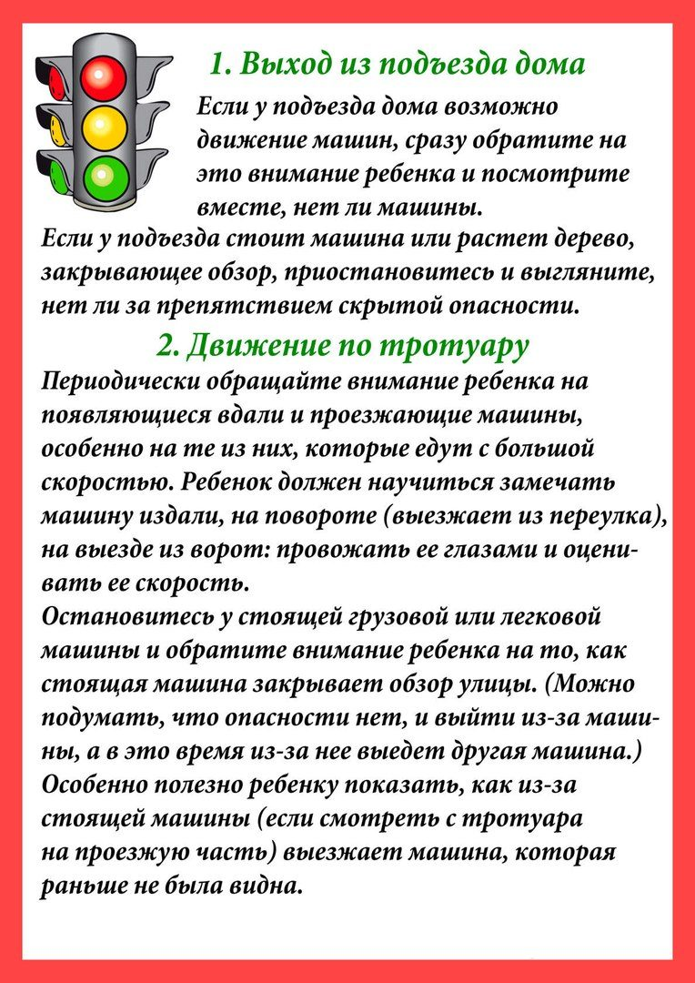](https://ok.ru/dk?cmd=PopLayerPhoto&st.layer.cmd=PopLayerPhotoOuter&st.layer.type=GROUP&st.layer.revNav=off&st.layer.limitedUi=false&st.layer.closeLayers=off&st.layer.sphotoIds=870297243727;870297243471;870297243215;870297242959;870297242703;870297242447&st.layer.showNav=on&st.layer.photoAlbumId=52636063039567&st.layer.epm=off&st.layer.photoId=870297243471&st.layer.opl=off&st.layer.navStartPhotoId=870297243471&st.layer.sbd=off&st.cmd=userMain&st._aid=GroupTopicLayer_openPhotoLayer)

[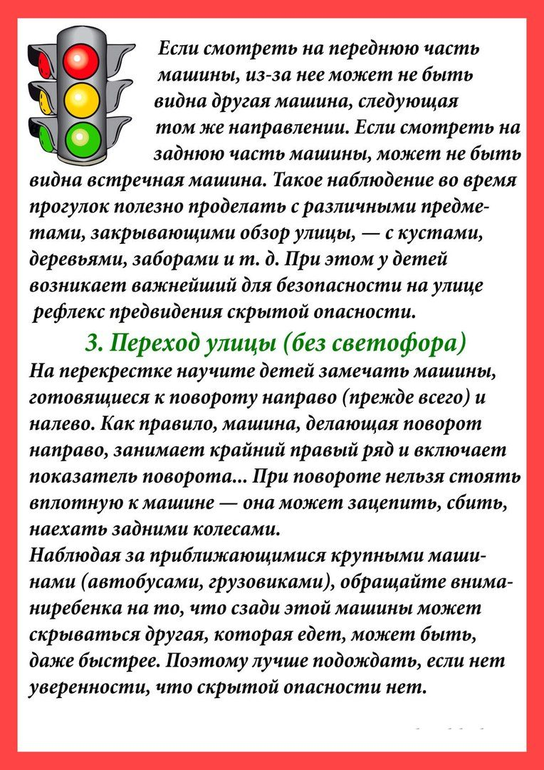](https://ok.ru/dk?cmd=PopLayerPhoto&st.layer.cmd=PopLayerPhotoOuter&st.layer.type=GROUP&st.layer.revNav=off&st.layer.limitedUi=false&st.layer.closeLayers=off&st.layer.sphotoIds=870297243727;870297243471;870297243215;870297242959;870297242703;870297242447&st.layer.showNav=on&st.layer.photoAlbumId=52636063039567&st.layer.epm=off&st.layer.photoId=870297243215&st.layer.opl=off&st.layer.navStartPhotoId=870297243215&st.layer.sbd=off&st.cmd=userMain&st._aid=GroupTopicLayer_openPhotoLayer)

[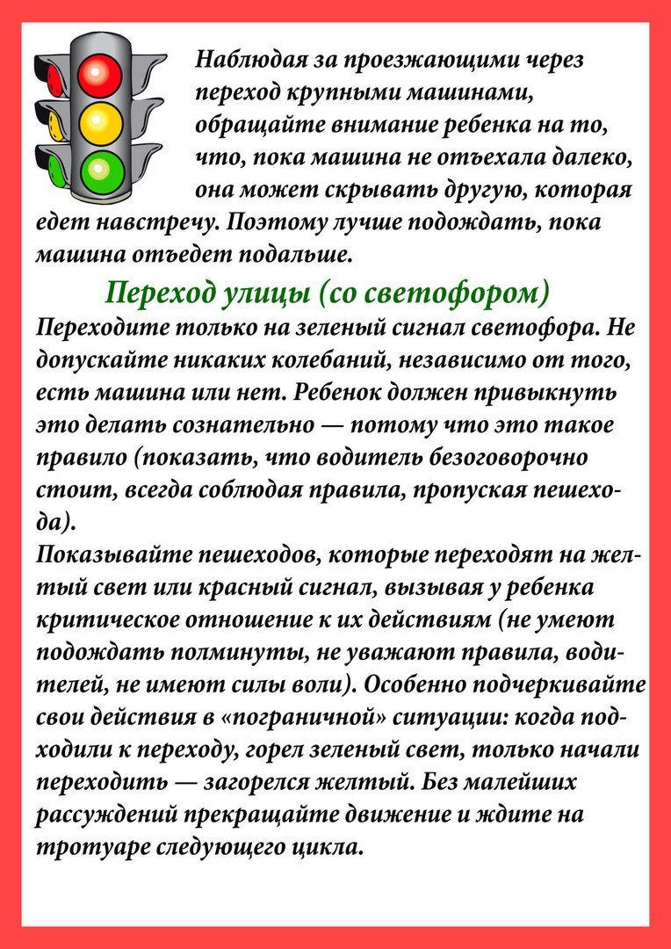](https://ok.ru/dk?cmd=PopLayerPhoto&st.layer.cmd=PopLayerPhotoOuter&st.layer.type=GROUP&st.layer.revNav=off&st.layer.limitedUi=false&st.layer.closeLayers=off&st.layer.sphotoIds=870297243727;870297243471;870297243215;870297242959;870297242703;870297242447&st.layer.showNav=on&st.layer.photoAlbumId=52636063039567&st.layer.epm=off&st.layer.photoId=870297242959&st.layer.opl=off&st.layer.navStartPhotoId=870297242959&st.layer.sbd=off&st.cmd=userMain&st._aid=GroupTopicLayer_openPhotoLayer)

[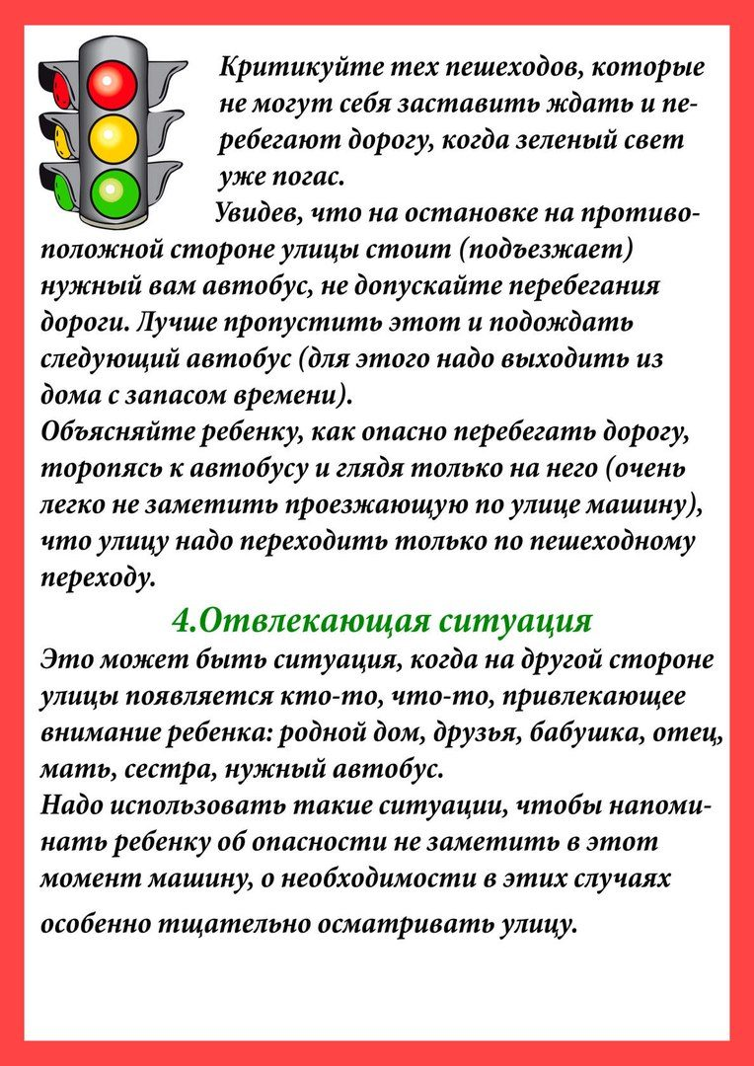](https://ok.ru/dk?cmd=PopLayerPhoto&st.layer.cmd=PopLayerPhotoOuter&st.layer.type=GROUP&st.layer.revNav=off&st.layer.limitedUi=false&st.layer.closeLayers=off&st.layer.sphotoIds=870297243727;870297243471;870297243215;870297242959;870297242703;870297242447&st.layer.showNav=on&st.layer.photoAlbumId=52636063039567&st.layer.epm=off&st.layer.photoId=870297242703&st.layer.opl=off&st.layer.navStartPhotoId=870297242703&st.layer.sbd=off&st.cmd=userMain&st._aid=GroupTopicLayer_openPhotoLayer)

[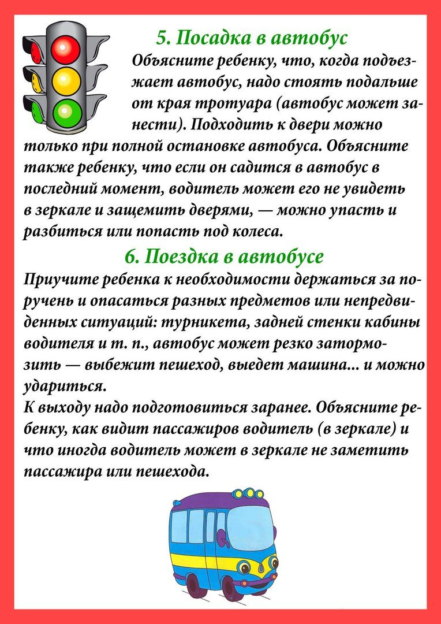](https://ok.ru/dk?cmd=PopLayerPhoto&st.layer.cmd=PopLayerPhotoOuter&st.layer.type=GROUP&st.layer.revNav=off&st.layer.limitedUi=false&st.layer.closeLayers=off&st.layer.sphotoIds=870297243727;870297243471;870297243215;870297242959;870297242703;870297242447&st.layer.showNav=on&st.layer.photoAlbumId=52636063039567&st.layer.epm=off&st.layer.photoId=870297242447&st.layer.opl=off&st.layer.navStartPhotoId=870297242447&st.layer.sbd=off&st.cmd=userMain&st._aid=GroupTopicLayer_openPhotoLayer)