[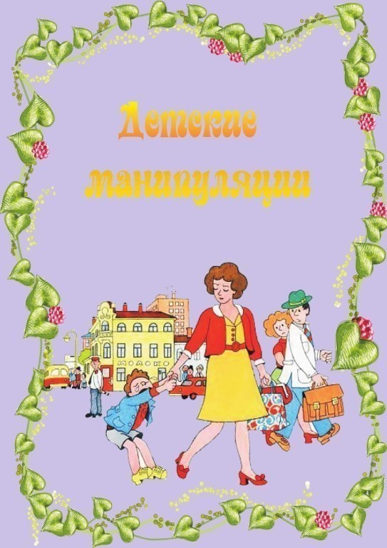](https://ok.ru/dk?cmd=PopLayerPhoto&st.layer.cmd=PopLayerPhotoOuter&st.layer.type=GROUP&st.layer.revNav=off&st.layer.limitedUi=false&st.layer.closeLayers=off&st.layer.sphotoIds=870961601588;870961601844;870961602100;870961602356;870961602612;870961602868;870961603124;870961603380;870961603636;870961603892&st.layer.showNav=on&st.layer.photoAlbumId=57249062780980&st.layer.epm=off&st.layer.photoId=870961601588&st.layer.opl=off&st.layer.navStartPhotoId=870961601588&st.layer.sbd=off&st.cmd=userMain&st._aid=GroupTopicLayer_openPhotoLayer)

[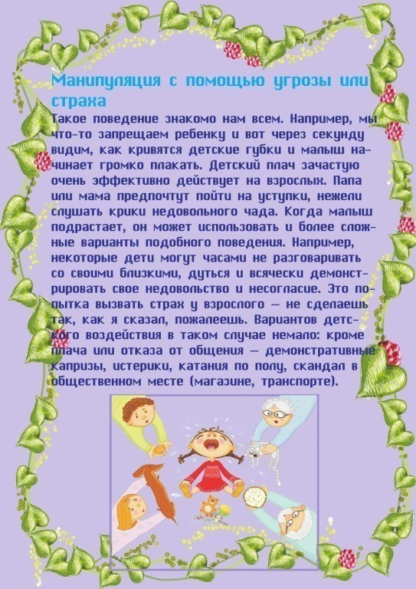](https://ok.ru/dk?cmd=PopLayerPhoto&st.layer.cmd=PopLayerPhotoOuter&st.layer.type=GROUP&st.layer.revNav=off&st.layer.limitedUi=false&st.layer.closeLayers=off&st.layer.sphotoIds=870961601588;870961601844;870961602100;870961602356;870961602612;870961602868;870961603124;870961603380;870961603636;870961603892&st.layer.showNav=on&st.layer.photoAlbumId=57249062780980&st.layer.epm=off&st.layer.photoId=870961601844&st.layer.opl=off&st.layer.navStartPhotoId=870961601844&st.layer.sbd=off&st.cmd=userMain&st._aid=GroupTopicLayer_openPhotoLayer)

[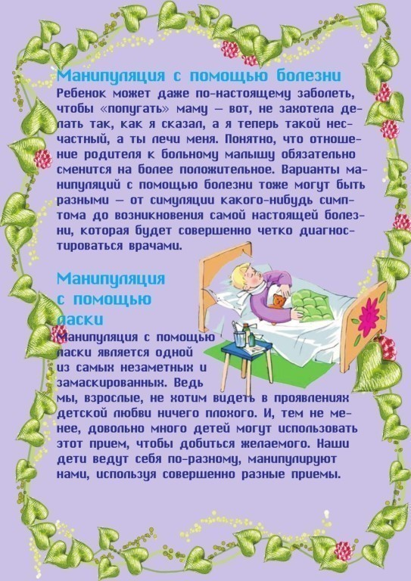](https://ok.ru/dk?cmd=PopLayerPhoto&st.layer.cmd=PopLayerPhotoOuter&st.layer.type=GROUP&st.layer.revNav=off&st.layer.limitedUi=false&st.layer.closeLayers=off&st.layer.sphotoIds=870961601588;870961601844;870961602100;870961602356;870961602612;870961602868;870961603124;870961603380;870961603636;870961603892&st.layer.showNav=on&st.layer.photoAlbumId=57249062780980&st.layer.epm=off&st.layer.photoId=870961602100&st.layer.opl=off&st.layer.navStartPhotoId=870961602100&st.layer.sbd=off&st.cmd=userMain&st._aid=GroupTopicLayer_openPhotoLayer)

[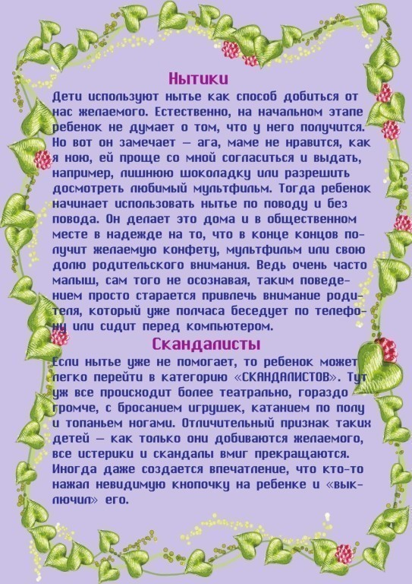](https://ok.ru/dk?cmd=PopLayerPhoto&st.layer.cmd=PopLayerPhotoOuter&st.layer.type=GROUP&st.layer.revNav=off&st.layer.limitedUi=false&st.layer.closeLayers=off&st.layer.sphotoIds=870961601588;870961601844;870961602100;870961602356;870961602612;870961602868;870961603124;870961603380;870961603636;870961603892&st.layer.showNav=on&st.layer.photoAlbumId=57249062780980&st.layer.epm=off&st.layer.photoId=870961602356&st.layer.opl=off&st.layer.navStartPhotoId=870961602356&st.layer.sbd=off&st.cmd=userMain&st._aid=GroupTopicLayer_openPhotoLayer)

[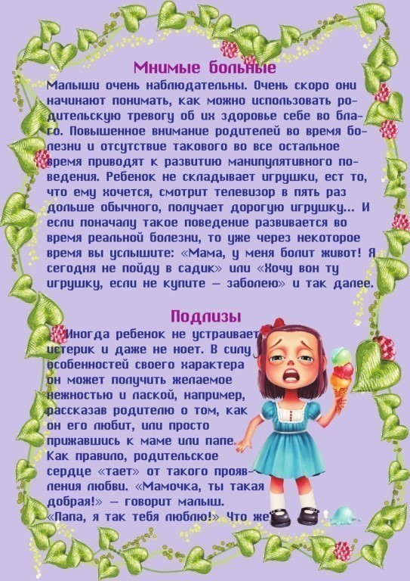](https://ok.ru/dk?cmd=PopLayerPhoto&st.layer.cmd=PopLayerPhotoOuter&st.layer.type=GROUP&st.layer.revNav=off&st.layer.limitedUi=false&st.layer.closeLayers=off&st.layer.sphotoIds=870961601588;870961601844;870961602100;870961602356;870961602612;870961602868;870961603124;870961603380;870961603636;870961603892&st.layer.showNav=on&st.layer.photoAlbumId=57249062780980&st.layer.epm=off&st.layer.photoId=870961602612&st.layer.opl=off&st.layer.navStartPhotoId=870961602612&st.layer.sbd=off&st.cmd=userMain&st._aid=GroupTopicLayer_openPhotoLayer)

[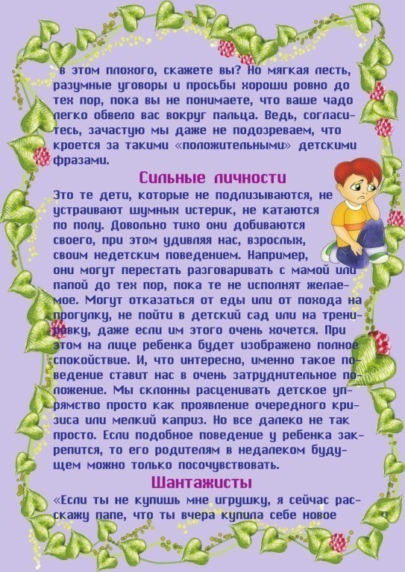](https://ok.ru/dk?cmd=PopLayerPhoto&st.layer.cmd=PopLayerPhotoOuter&st.layer.type=GROUP&st.layer.revNav=off&st.layer.limitedUi=false&st.layer.closeLayers=off&st.layer.sphotoIds=870961601588;870961601844;870961602100;870961602356;870961602612;870961602868;870961603124;870961603380;870961603636;870961603892&st.layer.showNav=on&st.layer.photoAlbumId=57249062780980&st.layer.epm=off&st.layer.photoId=870961602868&st.layer.opl=off&st.layer.navStartPhotoId=870961602868&st.layer.sbd=off&st.cmd=userMain&st._aid=GroupTopicLayer_openPhotoLayer)

[](https://ok.ru/dk?cmd=PopLayerPhoto&st.layer.cmd=PopLayerPhotoOuter&st.layer.type=GROUP&st.layer.revNav=off&st.layer.limitedUi=false&st.layer.closeLayers=off&st.layer.sphotoIds=870961601588;870961601844;870961602100;870961602356;870961602612;870961602868;870961603124;870961603380;870961603636;870961603892&st.layer.showNav=on&st.layer.photoAlbumId=57249062780980&st.layer.epm=off&st.layer.photoId=870961603124&st.layer.opl=off&st.layer.navStartPhotoId=870961603124&st.layer.sbd=off&st.cmd=userMain&st._aid=GroupTopicLayer_openPhotoLayer)

[](https://ok.ru/dk?cmd=PopLayerPhoto&st.layer.cmd=PopLayerPhotoOuter&st.layer.type=GROUP&st.layer.revNav=off&st.layer.limitedUi=false&st.layer.closeLayers=off&st.layer.sphotoIds=870961601588;870961601844;870961602100;870961602356;870961602612;870961602868;870961603124;870961603380;870961603636;870961603892&st.layer.showNav=on&st.layer.photoAlbumId=57249062780980&st.layer.epm=off&st.layer.photoId=870961603380&st.layer.opl=off&st.layer.navStartPhotoId=870961603380&st.layer.sbd=off&st.cmd=userMain&st._aid=GroupTopicLayer_openPhotoLayer)

[](https://ok.ru/dk?cmd=PopLayerPhoto&st.layer.cmd=PopLayerPhotoOuter&st.layer.type=GROUP&st.layer.revNav=off&st.layer.limitedUi=false&st.layer.closeLayers=off&st.layer.sphotoIds=870961601588;870961601844;870961602100;870961602356;870961602612;870961602868;870961603124;870961603380;870961603636;870961603892&st.layer.showNav=on&st.layer.photoAlbumId=57249062780980&st.layer.epm=off&st.layer.photoId=870961603636&st.layer.opl=off&st.layer.navStartPhotoId=870961603636&st.layer.sbd=off&st.cmd=userMain&st._aid=GroupTopicLayer_openPhotoLayer)

[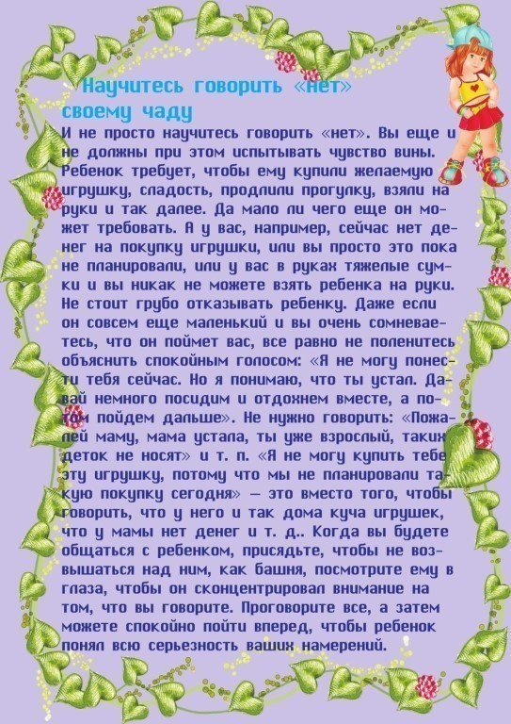](https://ok.ru/dk?cmd=PopLayerPhoto&st.layer.cmd=PopLayerPhotoOuter&st.layer.type=GROUP&st.layer.revNav=off&st.layer.limitedUi=false&st.layer.closeLayers=off&st.layer.sphotoIds=870961601588;870961601844;870961602100;870961602356;870961602612;870961602868;870961603124;870961603380;870961603636;870961603892&st.layer.showNav=on&st.layer.photoAlbumId=57249062780980&st.layer.epm=off&st.layer.photoId=870961603892&st.layer.opl=off&st.layer.navStartPhotoId=870961603892&st.layer.sbd=off&st.cmd=userMain&st._aid=GroupTopicLayer_openPhotoLayer)