[](https://ok.ru/dk?cmd=PopLayerPhoto&st.layer.cmd=PopLayerPhotoOuter&st.layer.type=GROUP&st.layer.revNav=off&st.layer.limitedUi=false&st.layer.closeLayers=off&st.layer.sphotoIds=865301595651;865301596419;865301595395;865301595907&st.layer.showNav=on&st.layer.photoAlbumId=55111578681347&st.layer.epm=off&st.layer.photoId=865301595651&st.layer.opl=off&st.layer.navStartPhotoId=865301595651&st.layer.sbd=off&st.cmd=userMain&st._aid=GroupTopicLayer_openPhotoLayer)

[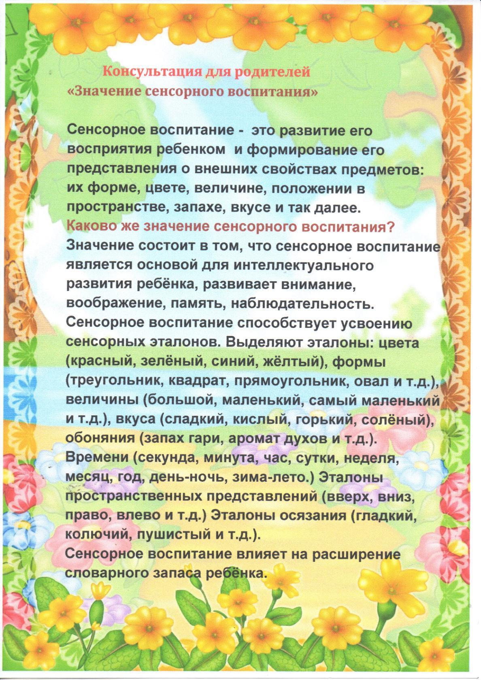](https://ok.ru/dk?cmd=PopLayerPhoto&st.layer.cmd=PopLayerPhotoOuter&st.layer.type=GROUP&st.layer.revNav=off&st.layer.limitedUi=false&st.layer.closeLayers=off&st.layer.sphotoIds=865301595651;865301596419;865301595395;865301595907&st.layer.showNav=on&st.layer.photoAlbumId=55111578681347&st.layer.epm=off&st.layer.photoId=865301596419&st.layer.opl=off&st.layer.navStartPhotoId=865301596419&st.layer.sbd=off&st.cmd=userMain&st._aid=GroupTopicLayer_openPhotoLayer)

[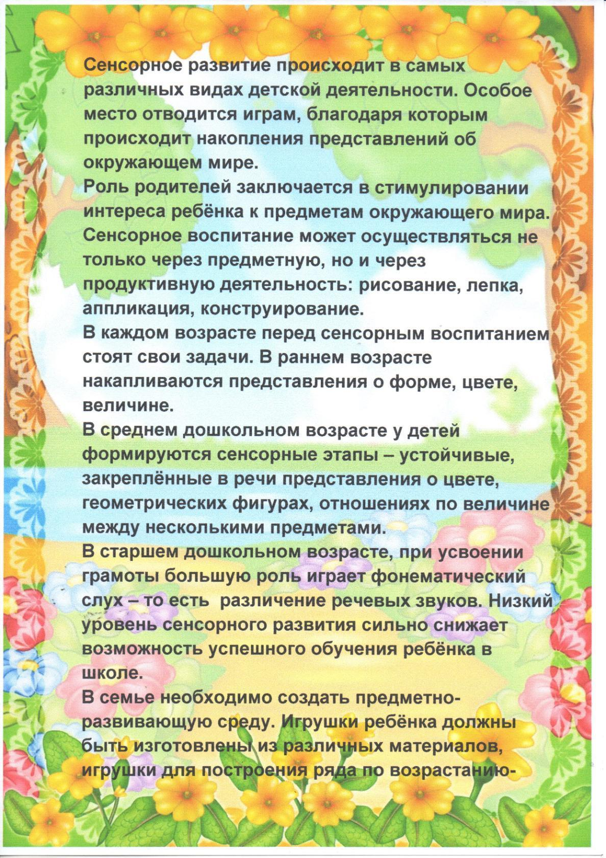](https://ok.ru/dk?cmd=PopLayerPhoto&st.layer.cmd=PopLayerPhotoOuter&st.layer.type=GROUP&st.layer.revNav=off&st.layer.limitedUi=false&st.layer.closeLayers=off&st.layer.sphotoIds=865301595651;865301596419;865301595395;865301595907&st.layer.showNav=on&st.layer.photoAlbumId=55111578681347&st.layer.epm=off&st.layer.photoId=865301595395&st.layer.opl=off&st.layer.navStartPhotoId=865301595395&st.layer.sbd=off&st.cmd=userMain&st._aid=GroupTopicLayer_openPhotoLayer)

[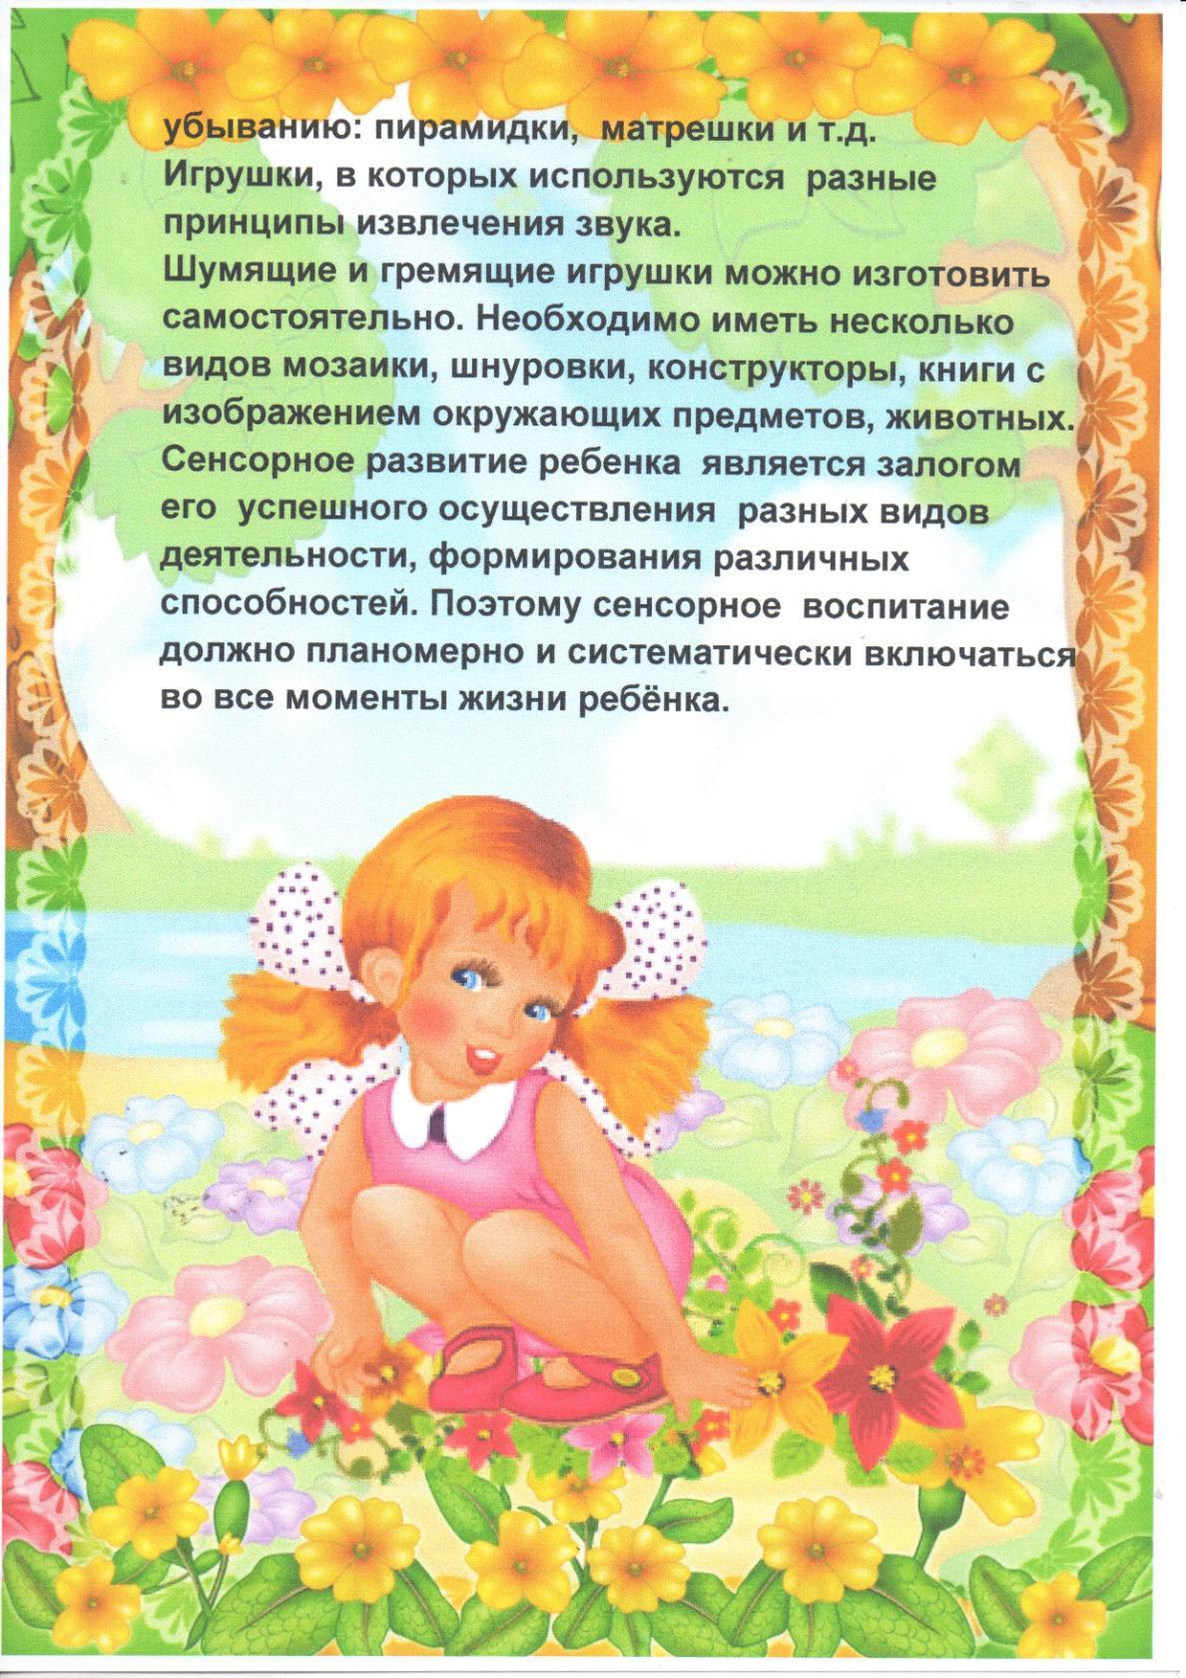](https://ok.ru/dk?cmd=PopLayerPhoto&st.layer.cmd=PopLayerPhotoOuter&st.layer.type=GROUP&st.layer.revNav=off&st.layer.limitedUi=false&st.layer.closeLayers=off&st.layer.sphotoIds=865301595651;865301596419;865301595395;865301595907&st.layer.showNav=on&st.layer.photoAlbumId=55111578681347&st.layer.epm=off&st.layer.photoId=865301595907&st.layer.opl=off&st.layer.navStartPhotoId=865301595907&st.layer.sbd=off&st.cmd=userMain&st._aid=GroupTopicLayer_openPhotoLayer)