[](https://ok.ru/dk?cmd=PopLayerPhoto&st.layer.cmd=PopLayerPhotoOuter&st.layer.type=GROUP&st.layer.revNav=off&st.layer.limitedUi=false&st.layer.sphotoIds=866589006415;866589006159;866589005903;866589005647&st.layer.showNav=on&st.layer.photoAlbumId=52636063039567&st.layer.epm=off&st.layer.photoId=866589006415&st.layer.opl=off&st.layer.navStartPhotoId=866589006415&st.layer.sbd=off&st.cmd=userMain&st._aid=GroupTopicLayer_openPhotoLayer)

[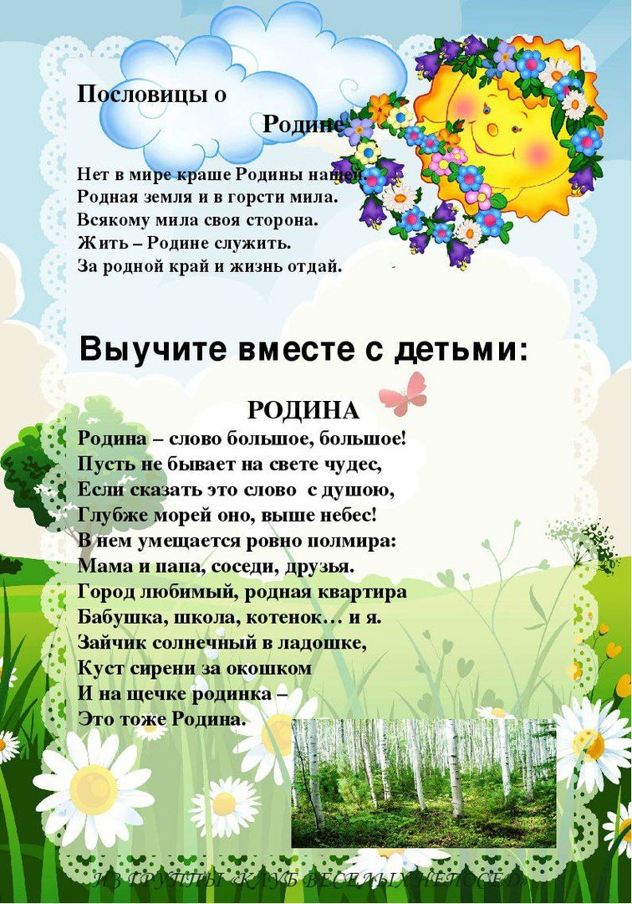](https://ok.ru/dk?cmd=PopLayerPhoto&st.layer.cmd=PopLayerPhotoOuter&st.layer.type=GROUP&st.layer.revNav=off&st.layer.limitedUi=false&st.layer.sphotoIds=866589006415;866589006159;866589005903;866589005647&st.layer.showNav=on&st.layer.photoAlbumId=52636063039567&st.layer.epm=off&st.layer.photoId=866589006159&st.layer.opl=off&st.layer.navStartPhotoId=866589006159&st.layer.sbd=off&st.cmd=userMain&st._aid=GroupTopicLayer_openPhotoLayer)

[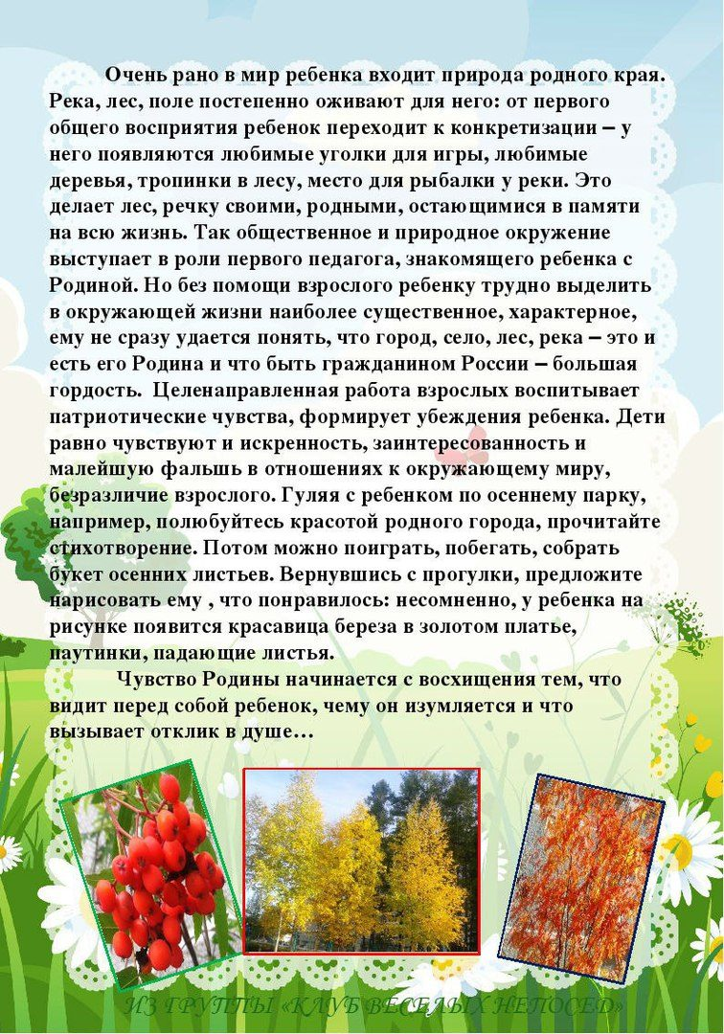](https://ok.ru/dk?cmd=PopLayerPhoto&st.layer.cmd=PopLayerPhotoOuter&st.layer.type=GROUP&st.layer.revNav=off&st.layer.limitedUi=false&st.layer.sphotoIds=866589006415;866589006159;866589005903;866589005647&st.layer.showNav=on&st.layer.photoAlbumId=52636063039567&st.layer.epm=off&st.layer.photoId=866589005903&st.layer.opl=off&st.layer.navStartPhotoId=866589005903&st.layer.sbd=off&st.cmd=userMain&st._aid=GroupTopicLayer_openPhotoLayer)

[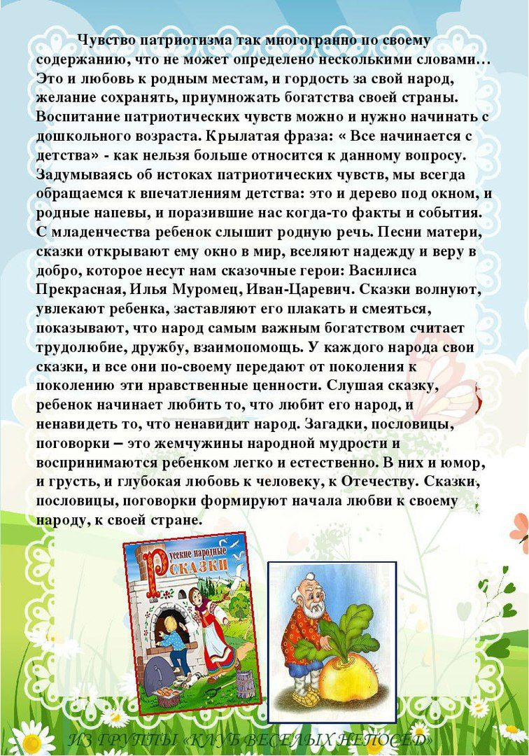](https://ok.ru/dk?cmd=PopLayerPhoto&st.layer.cmd=PopLayerPhotoOuter&st.layer.type=GROUP&st.layer.revNav=off&st.layer.limitedUi=false&st.layer.sphotoIds=866589006415;866589006159;866589005903;866589005647&st.layer.showNav=on&st.layer.photoAlbumId=52636063039567&st.layer.epm=off&st.layer.photoId=866589005647&st.layer.opl=off&st.layer.navStartPhotoId=866589005647&st.layer.sbd=off&st.cmd=userMain&st._aid=GroupTopicLayer_openPhotoLayer)